Step:1 open your lab and choose EC2 Instance

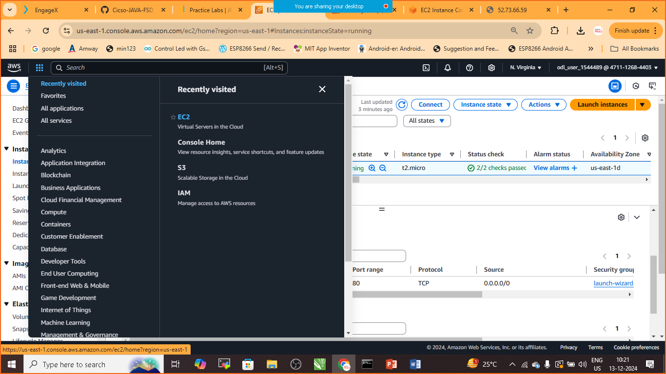

Step:2 Choose instance Running

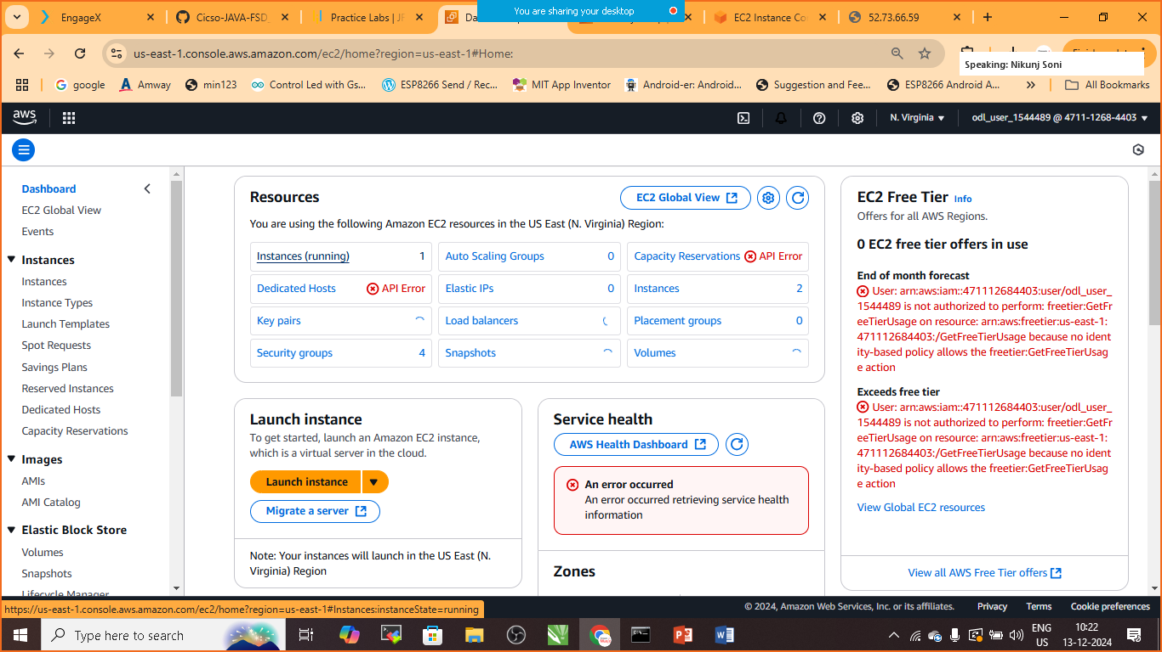

Step:3 Choose AWS Region (N.Verginia us-east-1)

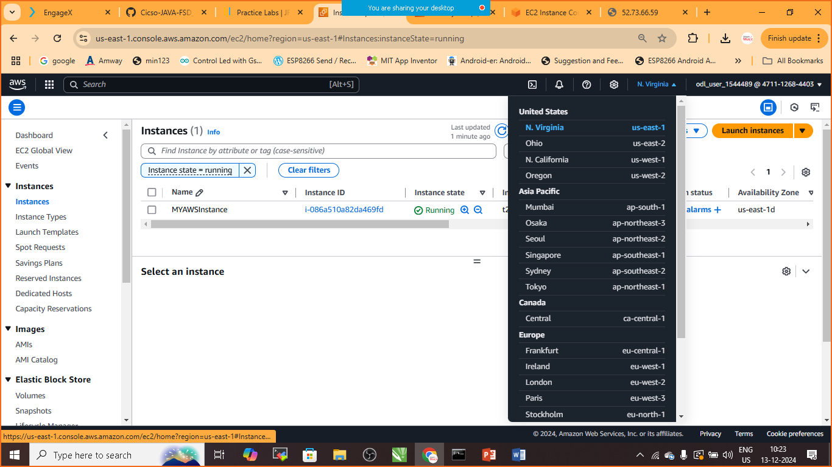

Step:4 Click on Launch Instance

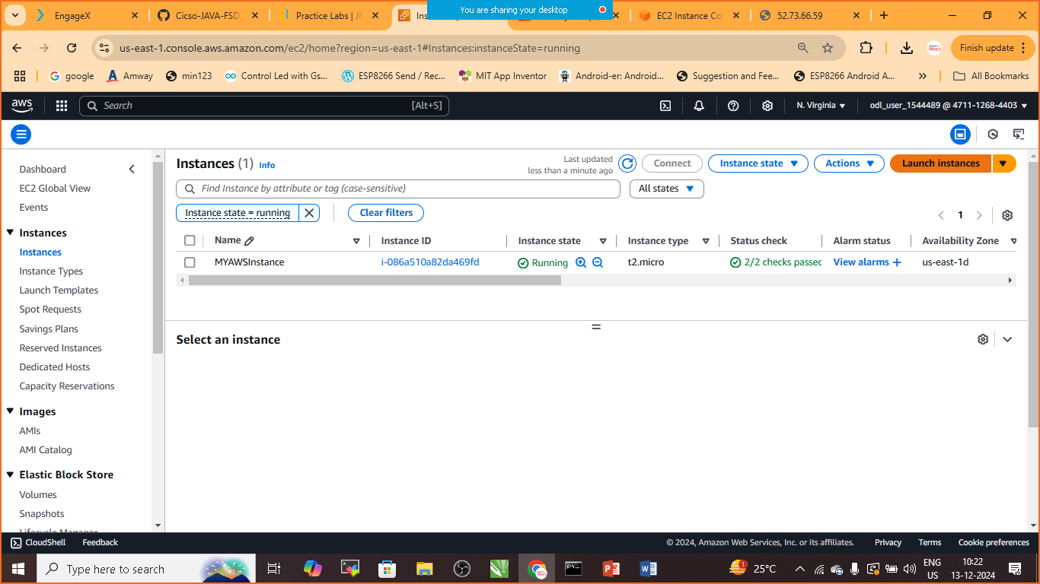

Step:5 Give the name : MyInstance

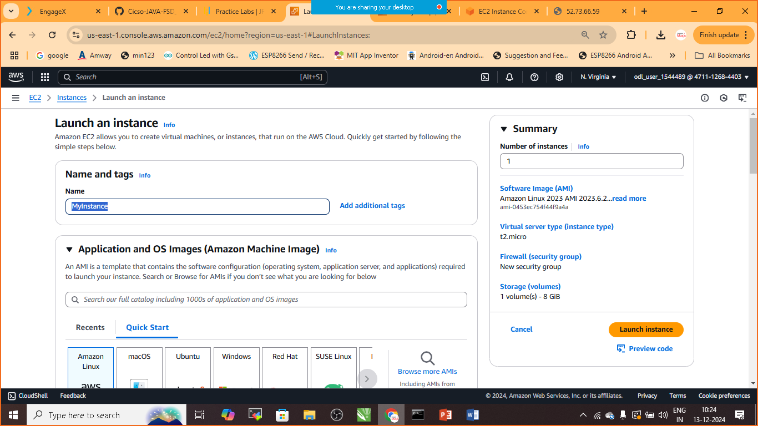

Step:6 choose Operating System for EC2 Instance (choose Default AWS Linux Instance)

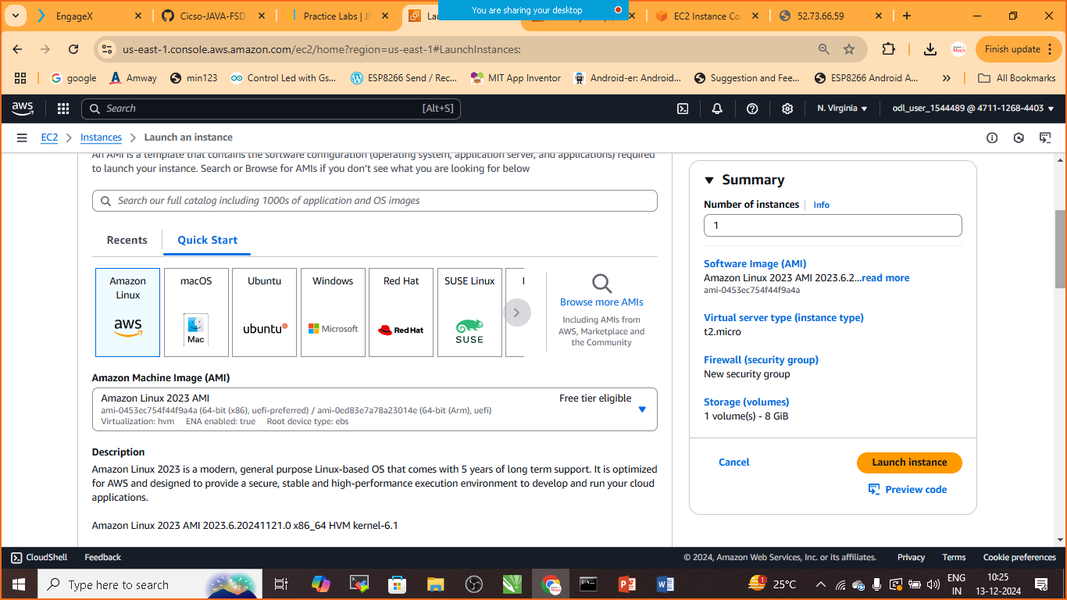

Step:7 Choose /Create KeyValue Pair

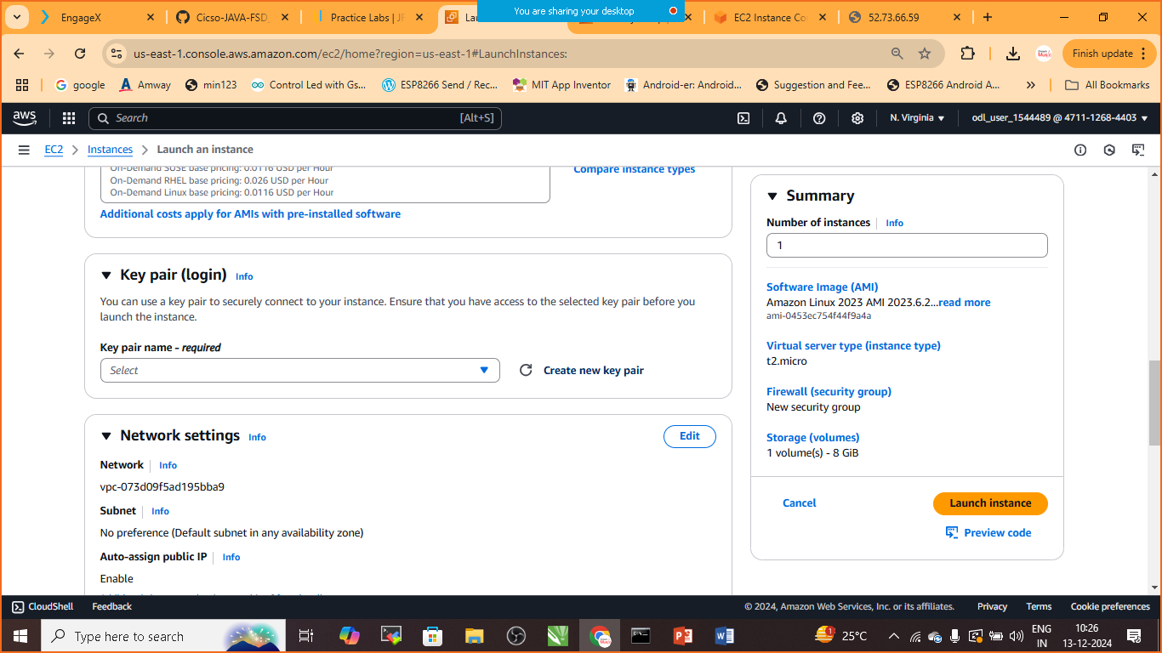

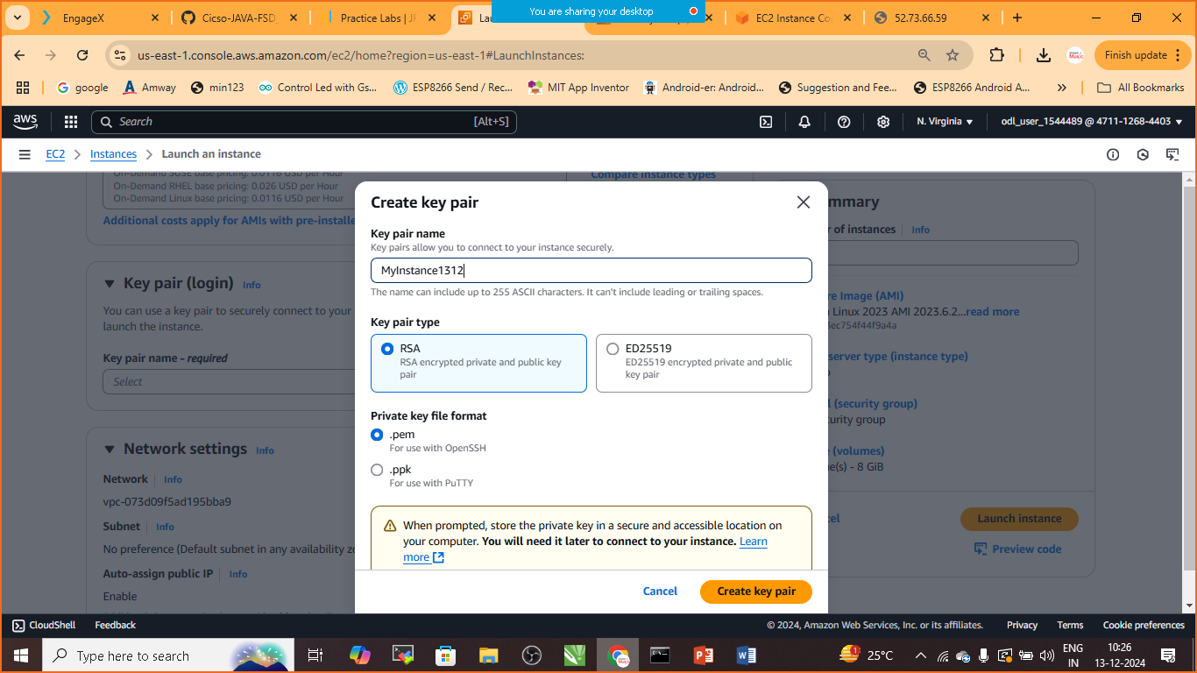

Save this Key Value Pair if you want to connect the AWS Instance with Your Local Machine

Step:8 Edit Network Security Group Rule

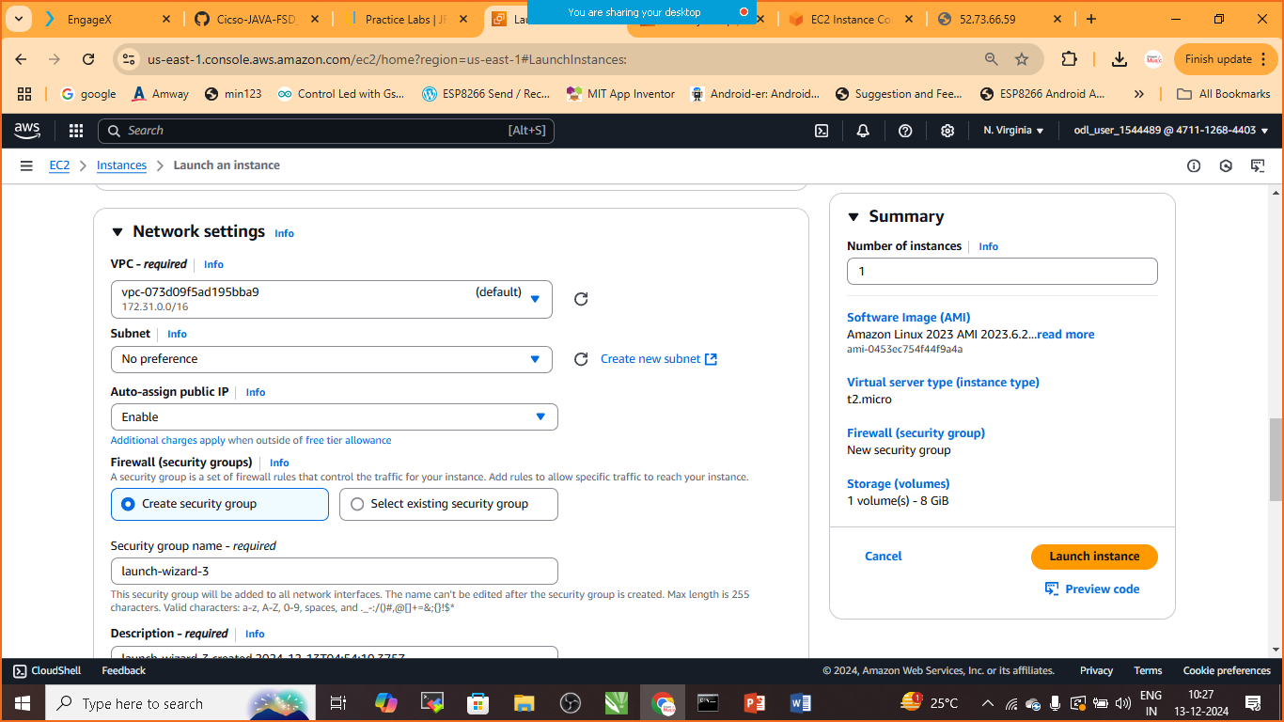

Click on Add SecurityGroup Rule

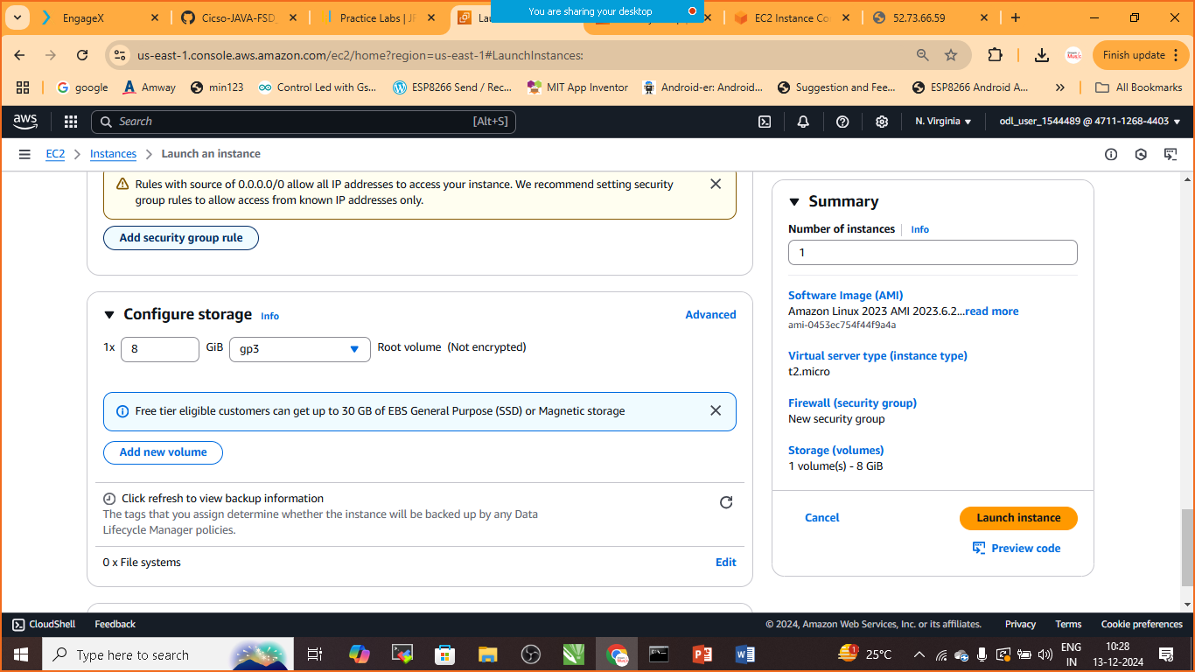

Add the given security port

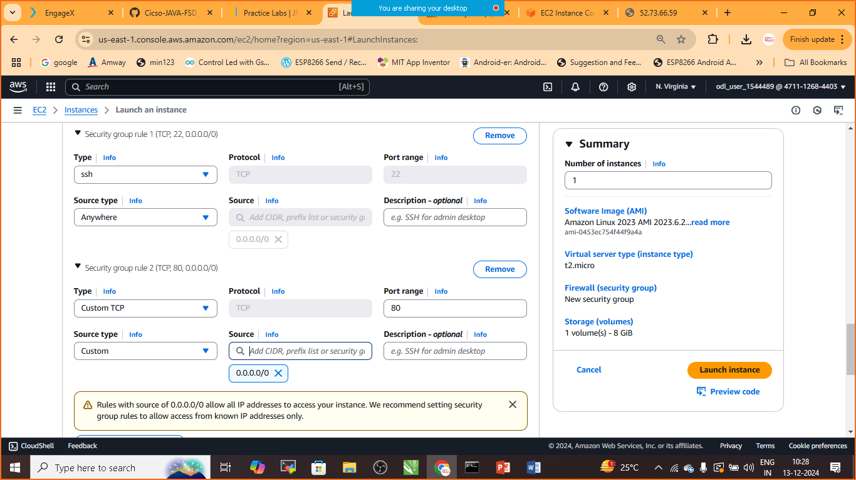

Step:9 Launch Instance

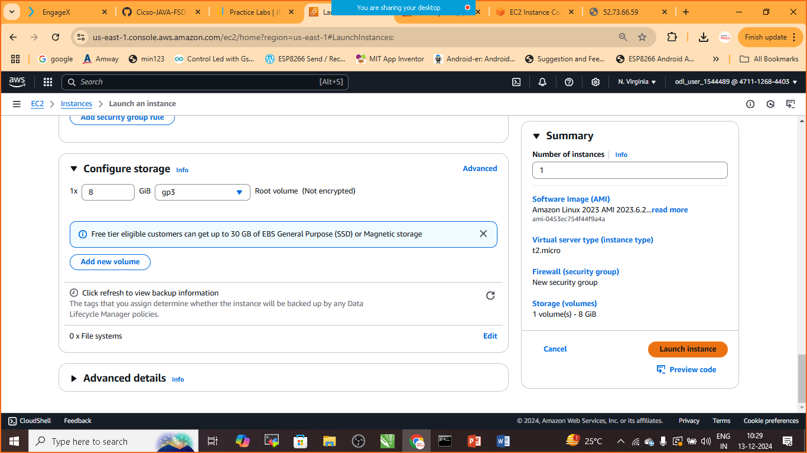

Step:10 Goto>Instances> choose the newly Created Instance>Connect

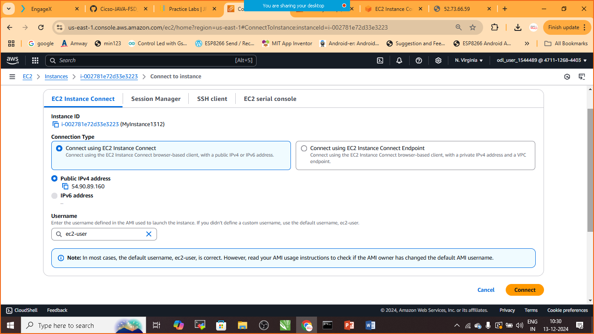

Again click on connect

* sudo su –
* yum install httpd –y
* cd /var/www/html
* vi index.html

press ‘i’ to insert into html page

<h1>Welcome to AWS Cloud</h1>

Press : esc

* :wq! + Hit Enter Button
* Service httpd start
* Curl localhost
* Goto> instance>copy public ip
* Goto> browser: publicip:80

If not getting out put: goto> security> inbound rule add the below rule

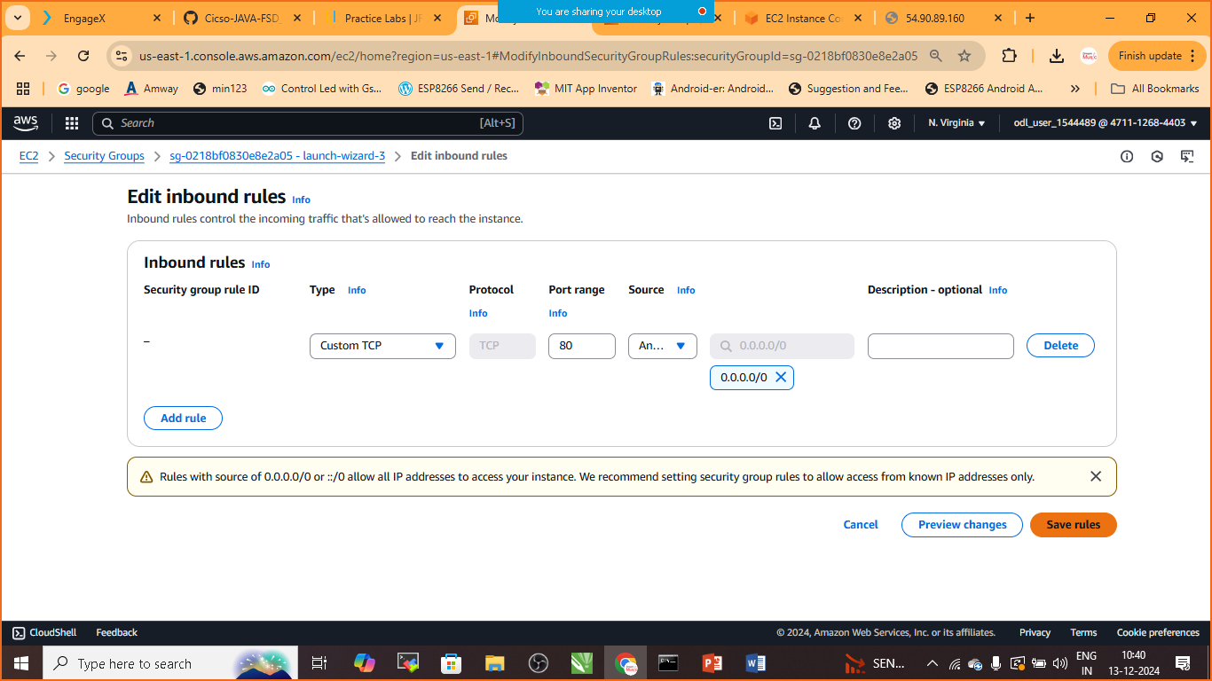

Step:10 Launch Browser: ip_add:80

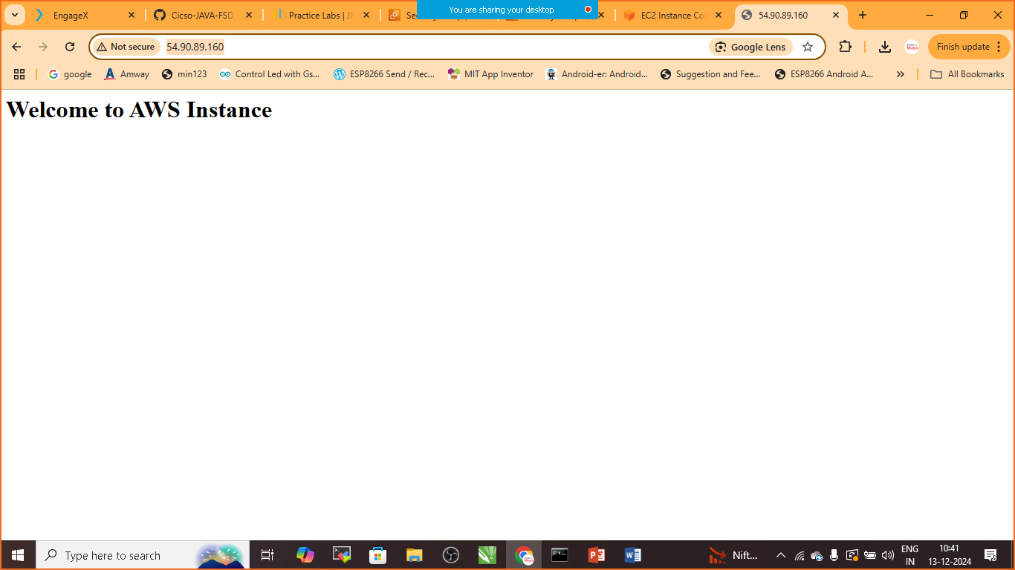

Add or remove volume to AWS EC2 Instance

* Create new EC2 Instance

LIST Available Disk

* Lsblk

To check if the volume has any data or not?

* sudo file –s /dev/name_of_disk //for me it is xvda1

to formate drive to ext4 partition system

* sudo mkfs –t ext4 /dev/xvdf

to change the name of directory

* sudo mkdir /newvolume

to mount newly prepared directory

* sudo mount /dev/name_of_your_disk(xvda1)/newvolume

to check the name has changed or not?

* Lsblk

To move to the new volume

* cd /newvolume
* lsblk

to unmount the drive

* cd ..
* sudo umonut /dev/name_of_your_disk(xvda1)

to check volume being unmounted or not

* lsblk